Knowledge Acquisition Document (KAD)

MyDamco

*Version 1.2*



Document Control

|  |  |
| --- | --- |
| **Document Title** | Knowledge Acquisition Document (KAD) for myDamco |
| **Description** | This document will be continuously updated during the KA phase and will be a deliverable to DAMCO at the end of KA Phase. |
| **Issue Date** | 10-Feb-2016 |
| **Originator** | TCS AMS Transition team |

|  |  |  |  |
| --- | --- | --- | --- |
| **Date Issued** | **Version** | **Author** | **Reason for Change** |
| 10-Feb-2016 | 1.0 | Richa Chawla | Draft Version |
| 11-Feb-2016 | 1.1 | Richa Chawla | Comments from IT-Kartellet incorporated |
| 12-Feb-2016 | 1.2 | Richa Chawla | Incorporated information received from Suzette |

Document Review History

|  |  |  |  |
| --- | --- | --- | --- |
| **Date of Review** | **Version Reviewed** | **Reviewed By** | **Review Description** |
| 11-Feb-2016 | 1.0 | Jakob Bo Larsen |  |
| 12-Feb-2016 | 1.9 | Suzette |  |
|  |  |  |  |

Contents

1 Application Summary / Fact Sheet 5

2 Application Understanding 7

2.1 Application Functional Overview 7

2.2 Key Features 9

2.2.1 Displaying the dashboard 9

2.2.2 Widgets 9

2.2.3 Navigation Menu 9

2.2.4 Internal News and announcements 9

2.2.5 E-Learning 10

2.2.6 Static Pages 10

2.2.7 Dashboard Templates 10

2.2.8 Piwik 10

2.3 Application Architecture overview 10

2.4 Key Entities / ER Diagram 11

2.5 Application Interfaces 12

2.5.1 ASP.NET Routing 12

2.5.2 Web Service 13

2.6 Application Security / Access mechanisms 13

2.6.1 Type of Access mechanisms in place 13

2.6.2 Authentication 13

2.6.3 Authorization 13

3 Application Documentation Availability 14

4 Technology / Environments Details 16

4.1 Application Technology Stack 16

4.2 Software / Licenses details 16

4.3 Development Tools 16

4.4 Details of Third Party Components used 16

4.5 Application Topology 17

4.6 Application Environments 17

5 Application Inventory 19

6 Application Configuration 20

6.1 Application Server Configuration 20

6.2 Configuration through Application GUI 20

6.3 Database Configuration 20

7 Supportability 21

7.1 Service Levels 21

7.2 Ticket flow 21

7.2.1 Incidents 21

7.2.2 Service Requests 21

7.3 Key Contacts 22

7.4 Configuration Management process 22

7.5 Release Management process 22

7.5.1 Release cycle (minor / major releases) 22

7.6 Alert Management 23

7.7 Housekeeping / Archival tasks 23

7.7.1 Backup Recovery and Archival 23

7.7.2 Scheduled Upgrades 24

7.7.3 Critical Jobs/Integration Needs/Schedules 24

7.7.4 Best Time to Bring Down the Applications for Maintenance/Outage 24

7.7.5 Performance and Availability 24

7.8 Other Recurring tasks (Daily / Weekly / Fortnightly / Monthly) 25

7.8.1 Batch Process monitoring 25

7.8.2 Interface monitoring 25

7.8.3 Other Application checks 25

7.9 Typical Issues / Resolution 26

# Application Summary / Fact Sheet

|  |  |
| --- | --- |
| **Application Id** |  |
| **Application Name** | MyDamco |
| **Application Extended Name** | MyDamco |
| **Short Description** | MyDamco is a web-based gateway into the Damco application landscape, for both customers and employees |
| **Status** | In Production |
| **Application Maturity / Commissioned Month/Year** | Mature, 2012 |
| **Core Business Processes** | * Other |
| **Portfolio** | Customer Interfaces |
| **Application Lifecycle Manager / Alternate ALM (if any)** | Santiago, Suzette Lacap <Suzette.Lacap-Santiago@damco.com> |
| **Portfolio Manager** | Taragano, Yildiz [yildiz.taragano@damco.com](mailto:yildiz.taragano@damco.com) |
| **Escalation Contact** | Santiago, Suzette Lacap <Suzette.Lacap-Santiago@damco.com> |
| **Business Process Owner** | Beukeveld, Saskia [Saskia.Beukeveld@damco.com](mailto:Saskia.Beukeveld@damco.com) |
| **Geographical Usage** | Global |
| **COTS / Bespoke** |  |
| **Implementation Platform / Technology** | Microsoft .Net, MVC Framework |
| **Programming Language** | C#, Javascript |
| **Database / Version** | SQL Server 2012 |
| **Application Criticality** | Medium |
| **Number of users** | ~ 35 000 |
| **Usage pattern** | Normal business hours |

# Application Understanding

## Application Functional Overview

MyDamco is a web-based gateway into the Damco application landscape, for both customers and employees. It provides navigation links to the Damco’s end users and a dashboard is to mimic publicly available portal services such as iGoogle.

All information in myDamco is provided by other Damco systems or 3party systems via SOAP services that are called when the users access the site, most of this information is cached for 10-15 minutes and the only persistent user data is widget locations and configuration.

It provides user interface to train internal staffs/super users using myDamco portal on:

* Damco Shipper
* Document Management
* Track & Trace
* Reporting
* Communication & Exception

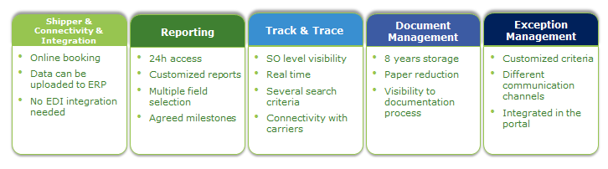

Figure 1: MyDamco connectivity to external applications

Data flow diagram that depicts MyDamco integration with other applications.

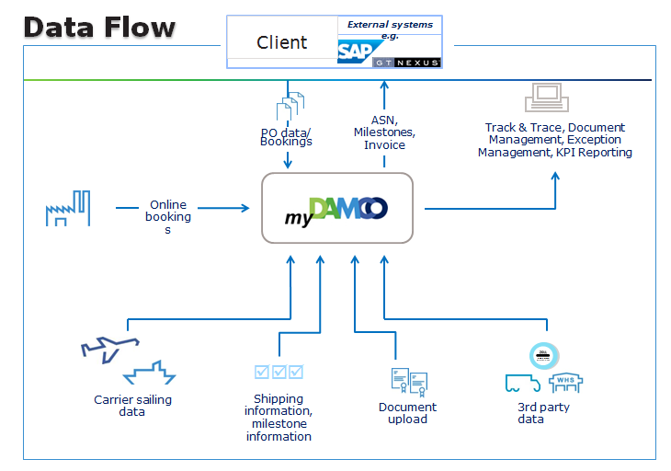

Figure 2: MyDamco: Data flow diagram

MyDamco web portal has been recognized by **Gartner** as one of the best customer portals in the logistics industry.

This diagram represents features of MyDamco value additions.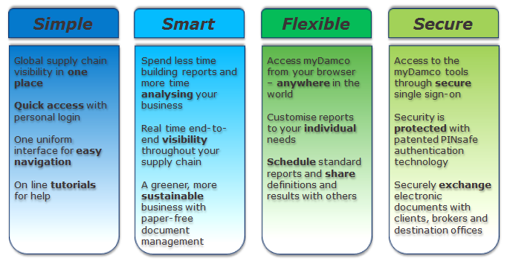

Figure 3: MyDamco Value Additions

## Key Features

This section contains key features of MyDamco application.

### Displaying the dashboard

The dashboard page can be considered the “main” page of myDamco.

### Widgets

Widgets are small windows you can place on your dashboard. Each widget shows different pieces of useful information, from news to available E-Learning courses. The widgets provides an overview of data from several different systems at one place – at your dashboard

### Navigation Menu

The navigation menu is at the top of the screen. The menu provides a convenient means of navigating to other Damco applications, changing between your available UAM roles and more.

The navigation menu shows links to other Damco applications. To navigate to an application, simply click its link. The list of application available in navigation menu depends on your access as per UAM-role.

### Internal News and announcements

The Damco News widget shows internal news stored in the database. This news are thus not fetched from an external service but managed by the myDamco application itself. Announcements are a special case of news and are handled by the same system.

### E-Learning

The purpose of the E-learning widget is to show "video" tutorials to the users, primarily teaching them how to use the various applications at Damco. In the widget, the user can choose between the available tutorials in a list and can click any of them to see the tutorial in full screen. These tutorials are flash files (.swf), so fundamentally this is a widget for showing flash files.

### Static Pages

A minor feature of myDamco is to serve static pages, such as those in the footer (Cookies, disclaimer, privacy policy and terms of use). Instead of creating a new HTML page in the project for these simple pages, they are stored in the database. It is possible to create new static pages from the administration tool at run-time.

Addition of new static page: It is possible to create a new database record for a static page using the Administration module but code change will be required to display that page on the application user interface. The new added page can then be configured through Administration module.

### Dashboard Templates

A dashboard template is a special dashboard containing widgets, which will be copied onto a user’s dashboard, when the user’s dashboard is empty and the user is in the same role as the dashboard template applies to. This is instead of inserting the welcome widget when the user’s dashboard is empty.

### Piwik

MyDamco can optionally track user’s behavior using the open source Piwik tracker. It works similar to Google Analytics, but instead of storing the data in the cloud on Google’s servers, it is stored on Damco’s own servers.

## Application Architecture overview

MyDamco is divided into two main parts a backend application that runs on the server and a frontend application in JavaScript that runs in the client’s browser

The backend of the application is structured according to standard ASP.NET MVC architecture. Most of the C# code is in the controller classes. Much of the code to ensure the functioning of the application is on the client side as JavaScript. This means that most of the functionality in myDamco is exposed to the user as JSON services that in turn get their information from source systems such as reporting, document management, etc. via SOAP calls. Authentication and Authorization is provided by ADFS and UAM, This means that when a user logs into MyDamco, he is authenticated via Damco’s single sign-on solution, ADFS. ADFS is a token and claims based authentication solution, where users can gain access to systems and applications located across organizational boundaries. MyDamco contains both internal users (employees) and external users (customers). Internal users are stored in an Active Directory and the customers are stored in ADAM/AD LDS. Both of these directories are accessed via ADFS. The login and authentication works seamlessly across all of the applications MyDamco integrates with, meaning a user only have to login to MyDamco to gain access to the entire system portfolio MyDamco integrates with (Reporting, Document Management and Communication and Exceptions).

## Key Entities / ER Diagram

This section contains the details of key entities of MyDamco database and its entity-relationship diagram.

|  |  |
| --- | --- |
| Key Entity | Description |
| Navigation | This table contains one row per link to the applications in the navigation menu. These rows contains the URLs to the applications, the rights required for the links to be displayed, the order of the links, etc. |
| Widget | This table has a row for each type of widget that exists in myDamco |
| WidgetInstance | This contains all widget instances that any user has on their dashboard. Since a user has a dashboard for each role, the login and role columns together defines the dashboard at which the widget is placed. The DashboardColumn and DashboardPriority defines the widgets position on that dashboard |
| WidgetInstanceHistory | This stores the timelines of when a particular user added or deleted a widget from the dashboard |
| NewsItem | The internal news items as well as all announcements are stored in this table |
| NewsCategory | Every news item belongs to a news category. By default there is a category for the Damco News widget and for announcements. |
| Downtime | One or more downtime entries can be created as part of an announcement. They are stored in this table, along with a foreign key to the announcement (News item) they belong to |
| Page | This table is for storing simple static pages. Each page has a title and a body (HTML), as well as a Uid which is used for the URL by which they are accessed |
| ELMAH_Error | This is where the error log of the ELMAH framework is stored. This table records exceptions occurring during the execution of the myDamco application |
| Settings | This is a table storing some myDamco settings which can be changed dynamically from the admin tool. |
| DashboardTemplates | This stores one row per dashboard template. The widget-instances themselves in the dashboard template are stored in the WidgetInstance table under a special username |

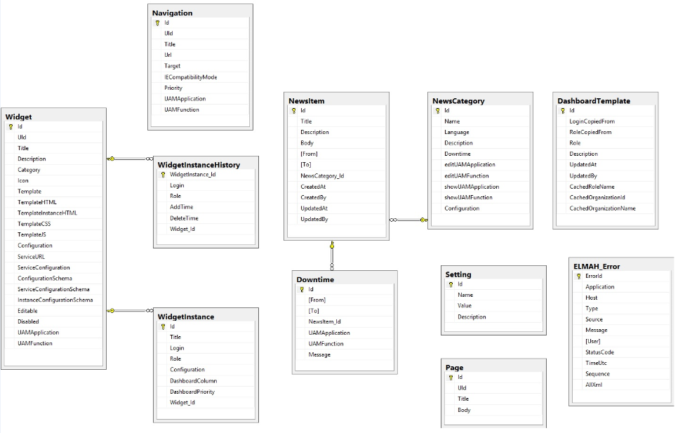

Figure 4: MyDamco E-R Diagram

## Application Interfaces

This section specifies different ways by which MyDamco interacts with other applications.

### ASP.NET Routing

ASP.NET routing enables you to use URLs that do not have to map to specific files in a Web site. In ASP.NET routing, you can define URL patterns that map to request-handler files, but that do not necessarily include the names of those files in the URL.

MyDamco provides a convenient means of navigating to below applications by just clicking on application link name in navigation menu. When user clicks on link, it basically routes to an external application.

* Reporting
* Track and Trace
* Shipper
* Document Management
* Communication and Exceptions

### Web Service

Data in Document management and Reporting widgets are loaded through web services. MyDamco has WSDL link integrated and if user has access to Reporting (including Track & Trace) and Document Management applications, data is loaded for these widgets on their dashboards.

So this is basically a service URL through which widgets gets their data.

## Application Security / Access mechanisms

This section details about the security mechanism for accessing MyDamco application.

### Type of Access mechanisms in place

MyDamco use the ADFS (Active Directory Federation Services) single sign on solution for authentication (logging in) and UAM for authorization (user rights).

### Authentication

The ADFS **single sign on** solution is used for authentication on myDamco.

ADFS is not setup to protect every resource on the entire site from unauthenticated access. This is to be able to have certain pages which can be viewed without being logged in, such as the status page. Instead, protection is mainly based on the authorization attributes of the action methods in the controller classes.

### Authorization

After having logged in, UAM is used to determine which rights the user has been granted. Accordingly, user is able to see the dashboard and widgets as defined for user’s role.

# Application Documentation Availability

|  |  |  |  |  |
| --- | --- | --- | --- | --- |
| **Document Type** | **Availability** | **Name of Document** | **Application Completeness Score (1-5)** | **Remarks** |
| Requirements Document | Yes | SRS | 5 | MyDamco System Documentation v1_2 (myDamco4.6.0) |
| Requirements Document | No | Use Cases |  |  |
| Environment set up document | Yes | Environment set-up guide | 5 | Development  Operations |
| Design Document | Yes | User Interface specifications | 5 | MyDamco user guide v1_2 (myDamco4.6.0)  MyDamco admin guide v2_1 (myDamco4.6.0) |
| Design Document | Yes | Interface Specifications | 5 | MyDamco admin guide v2_1 (myDamco4.6.0)  hardware_software_requirements_mydamco_1_3 |
| Operational Document | No | Support Procedures document / Daily tasks / KEDB |  |  |
| Operational Document | Yes | Monitoring procedures | 4 | Damco Aurora_MyDamco_Operational Handbook V1.0 |
| Operational Document | Yes | Installation & Configuration guide | 5 | myDamco UPDATE installation Guide  myDamco DATABASE UPDATE installation Guide |
| Operational Document | Yes | Release notes | 5 | Release Notes 4.6.0  Changelog |
| Testing documentation | Yes | Regression Test cases | 5 | Regression Test Cases for myDamco |
| Testing documentation | Yes | Automation Test cases | 4 | Selenium unit test cases are available for automation testing |

# Technology / Environments Details

## Application Technology Stack

This section contains technology stack of MyDamco application. MyDamco is based on .net MVC architecture with SQL Server 2012 as database engine.

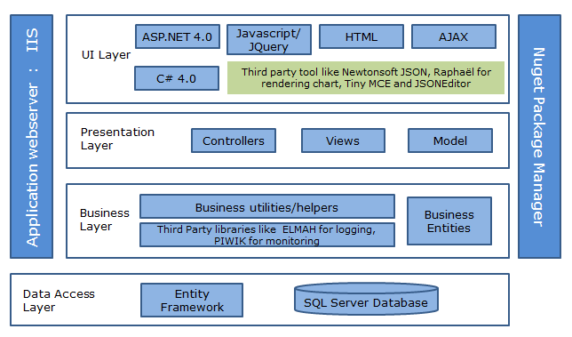

Figure 5: MyDamco Technology Stack

## Software / Licenses details

Not applicable

## Development Tools

Tools used for application and database development for MyDamco are:

* Visual Studio 2012
* SQL Server Management Studio 2012

## Details of Third Party Components used

Third part freeware tools used for MyDamco application development are:

* ELMAH for logging
* Newtonsoft JSON for working with JSON
* NuGET package manager
* Raphaël for rendering the pie chart
* Tiny MCE for JSONEditor and HTMLEditor for Static pages
* Piwik for application analytics and monitoring

## Application Topology

The production environment consists of two independent webservers hosting the application behind a load balancer, as well as a dedicated server for running the database.

MyDamco application runs on each web server and the database on data server.

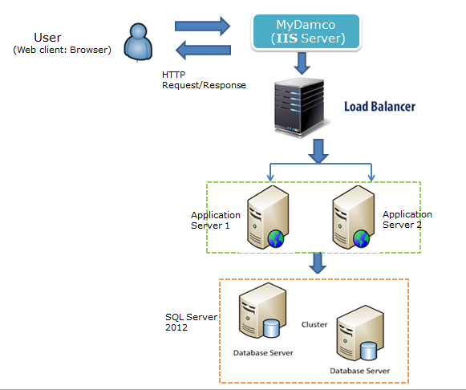

Figure 6: MyDamco Topology Diagram

## Application Environments

MyDamco is hosted on four environments. Environment details along with application URL is as below.

* **Test Environment**: <https://test-portal.damco.com/>

<https://test-portal.damco.com/integration/> *(link to mimic Integration environment)*

<https://test-portal.damco.com/preprod/> *(link to mimic Pre-Production environment)*

<https://test-portal.damco.com/prod/> *(link to mimic Production environment)*

* **Integration** **Environment**: https://integration-portal.damco.com/
* **Pre-Production Environment**: https://preproduction-portal.damco.com/
* **Production Environment**: https://portal.damco.com/

The table below covers details of all environments and its server details.

|  |  |  |  |
| --- | --- | --- | --- |
| Role | MyDamco 'Server Name' | IP | Environment |
| Loadbalancer | test external Loadbalancer | 193.163.252.165 | Test |
| Application | scrbmtadkcph016.crb.apmoller.net | 10.255.220.19 | Test |
| Database | scrbmtadkcph016.crb.apmoller.net | 10.255.220.19 | Test |
| Loadbalancer | integration-portal.damco.com | 193.163.252.18 | Integration |
| Application | scrbflxdkcph001.crb.apmoller.net | 10.255.220.75 | Integration |
| Application | scrbflxdkcph002.crb.apmoller.net | 10.255.220.82 | Integration |
| Database | SCRBFLXDKCPH020 | 10.255.220.56 | Integration |
| Loadbalancer | preproduction-portal.damco.com | 193.163.252.19 | Pre-prod |
| Application | scrbflxdkcph100.crb.apmoller.net | 10.255.220.71 | Pre-prod |
| Application | scrbflxdkcph101.crb.apmoller.net | 10.255.220.90 | Pre-prod |
| Database | SCRBFLXDKCPH169 | 10.255.220.39 | Pre-prod |
| Loadbalancer | portal.damco.com | 193.163.252.20 | Prod |
| Application | scrbflxdkcph200.crb.apmoller.net | 10.255.221.122 | Prod |
| Application | scrbflxdkcph201.crb.apmoller.net | 10.255.221.129 | Prod |
| Database | SCRBFLXDKCPH269 | 10.255.221.117 | Prod |

# Application Inventory

This section covers details of MyDamco inventory is as below.

1. **User Interfaces List (GUI)**

Refer below documents for User interface details.

* MyDamco admin guide v2_1 (myDamco4.6.0)
* MyDamco user guide v1_2 (myDamco4.6.0)

 

1. **Batch Programs**

Not applicable

1. **SOA Services (if any)**

Not applicable

1. **DB Scripts**

Script files are available for creating MyDamco database and its base data for each environment. Attached SQL file contains script for schema creation for MyDamco.



1. **Configuration Files**

Refer Section 6 Application Configuration for details.

# Application Configuration

## Application Server Configuration

Application and server configurations are maintained in following configuration files:

* Web configuration file (web.config)
* Application configuration file (app.config)

## Configuration through Application GUI

Administration section of the application helps to maintain configuration through MyDamco User interface. User can set up the configurations for the following:

* Creating, editing and deleting news items for Damco News Widget from ‘Damco General News’ tab of the News section
* Creating, editing and deleting announcements from ‘MyDamco announcements’ tab of the News section
* Managing the applications in navigation menu i.e. application URL etc.
* Add a new widget for the dashboard. Edit and delete the settings of existing widgets
* Creating new dashboard templates
* Settings like Enable client logging, compress external menu java script, Piwik tracking can also be controlled from Administration section.

## Database Configuration

This section contains details of database tables which maintain application configurations.

* Settings
* Navigation
* Widgets

# Supportability

## Service Levels

The table below lists down details of service level agreement for MyDamco with DAMCO.

|  |  |
| --- | --- |
| Application | MyDamco |
| Incident Counts to L1/L1.5 | ~250 |
| User Queries/Service Request Counts to L1/L1.5 Team | 1200-1300 |
| Incident /Problem Counts to L2/L3 Team | Less Than 10 |
| User Queries /Service Request Counts to L2/L3 Team | Less than 5 |
| Support Release | One per quarter |
| Level 1 Services | Y |
| Level 1.5 Services | Y |
| Level 2 Support Services | Y |
| Level 3 Support Services | Y |
| L1/L1.5 Application Complexity t-shirt Size | Medium |
| L1/L1.5 Application Criticality t-shirt Size | Gold |
| L2/L3 Application Complexity t-shirt Size | Small |
| l2/L3 Application Criticality t-shirt Size | Gold |

Service level Commitment for old Criticality is as below

|  |  |  |  |  |  |
| --- | --- | --- | --- | --- | --- |
| Application Criticality | Type of Tickets | Priority 1 | Priority 2 | Priority 3 | Priority 4 |
| GOLD | Incidents | Applicable | Applicable | Applicable | Applicable |
| GOLD | Service Requests | Not Applicable | Not Applicable | Applicable | Applicable |

## Ticket flow

### Incidents

Incidents are logged in Service Now (SNOW).

### Service Requests

Service requests are logged in Service Now (SNOW).

## Key Contacts

This section contains details of key person information that need to be contacted in case of any concern or issues.

|  |  |  |
| --- | --- | --- |
| Team Name | Contact Person Name | Contact Person E-Mail Id |
| Development Team | Jakob Bo Larsen | [JBL@IT-KARTELLET.DK](mailto:JBL@IT-KARTELLET.DK) |
| DAMCO Team | Suzette Lacap Santiago | Suzette.Lacap-Santiago@damco.com |
| IBM Wintel Team | Suzette Lacap Santiago | Suzette.Lacap-Santiago@damco.com |

## Configuration Management process

This section contains details of the code management for MyDamco.

* Source code is maintained by development team with IT-Kartellet.
* IT-Kartellet is using GIT as version management tool for MyDamco code repository.
* Latest version of the code for Release 4.6.0 is shared with TCS.
* TCS team now has a copy of the code in their environment maintained on TCS SVN repository.

## Release Management process

This section describes about the Release management process in place for MyDamco application.

All the requirements for business or technical releases are logged into Focal point.

### Release cycle (minor / major releases)

This section covers process steps for managing a release for MyDamco application.

|  |  |  |  |
| --- | --- | --- | --- |
| Sno | Process Name | Current Process | Ownership |
| 1 | Requirement Gathering | Requirements are received via email from Suzette along with timelines plan. | Suzette |
| 2 | Development | Development by Jakob (IT Kartellet) on dev environment i.e. own local machine | Jakob |
| 3 | Unit Testing | No test cases written; unit testing done by Jakob.  (Selenium test cases present, but not used ; hence not latest updated) | Jakob |
| 4 | Test Env. Deployment | Deployment done by Jakob as on planned date. Jakob performs sanity testing on Test Env and then informs Suzette about test release sign off | Jakob |
| 5 | Integration Env. Deployment | Suzette confirms a timeline, accordingly to which Jakob deploys the release on Integration environment | Suzette/Jakob |
| 6 | SIT/HOAT | L1/L1.5 support team performs HOAT. They also do regression when major change is deployed | L1/1.5 support team |
| 7 | SIT/HOAT sign off | Release sign off is received over mail and no SIT/HOAT Report is published corresponding to it | Suzette |
| 8 | Pre-Production Environment deployment schedule | * Suzette informs over mail about Preproduction release date and accordingly Jakob prepares RFC for IBM infrastructure team. * Release package zipped folder is placed on server location by Jakob. * Server location and RFC is shared with Suzette | Suzette/Jakob |
| 9 | PreProduction Deployment | * Suzette shared RFC and package location information with IBM. * IBM owns the deployment activity. | IBM |
| 10 | Smoke testing –Preproduction | Jakob and Suzette performs smoke test. No test cases for Smoke testing | Suzette/Jakob |
| 11 | UAT (User Acceptance Testing) | L1/1.5 support team performs UAT | L1/1.5 Support team |
| 12 | Production Environment deployment schedule | * Suzette informs over mail about production release date and accordingly Jakob prepares RFC (Installation Guide). * Same release package zipped folder deployed on Pre-Production environment is used for deployment. * RFC is shared with Suzette | Suzette/Jakob |
| 13 | Production Deployment | Suzette shared RFC and package location information with IBM.  IBM owns the deployment | IBM |
| 14 | Smoke testing –production | Jakob and Suzette performs smoke test. No test cases for Smoke testing | Suzette/Jakob |
| 15 | Production Incidents | Approximately <10 incidents escalated to L2 team.  Incidents are captured in SNOW. | Suzette/Jakob |

## Alert Management

This section contains details of alert mechanisms in place to monitor MyDamco application.

1. BPV alert monitoring tool is used to monitor the status of MyDamco application. This monitors both application and server health of the application. It shows ‘Green’ status if application and server both are running fine, else it shows ‘Red’ status to mark an alert.

Application team needs to monitor the BPV tool on daily basis.

http://bpv.apmoller.net/bpv/framefavourite.do

1. There is web page in MyDamco application to monitor the health of application and the servers. This status page can be accessed by adding ‘/status’ suffix to application URL. This has been designed specifically for application team for their monitoring purpose.

## Housekeeping / Archival tasks

This section contains information of all housekeeping tasks for production environment.

### Backup Recovery and Archival

* A TSM client and TSM Schedule services are installed on each node.
* Separate TSM scheduler services are installed to configure backup for local and shared disks.
* TSM scheduler services which are installed to configure backup for shared disks are added as a cluster resource in their respective cluster group.
* A TDPSQL client is installed to backup MS SQL databases

|  |  |  |  |  |
| --- | --- | --- | --- | --- |
| Server Type | Machine | Backup Item | Backup Frequency | Recovery Mechanism |
| Mostly in Damco, there are Virtual machines (VM's) and the backups are done by using TSM4VE (TSM for Virtual Environments). So the TSM client installed on each machine are just used for backing up the event logs for security purpose. | TSM4VE, it is backing up all the drives in the machine (whether it is local or cluster). | TDPSQL is installed on all the SQL DB servers and backed up to TSM. The backup is scheduled in SQL jobs. There is no scheduler service running on window's servers for SQL backups. | The backup is scheduled to run non business hours and the Production servers’ daily backup data are retained for 14 days and Pre-prod (Dev, Test...etc) are retained for 7 days. | For recovery(Restore)-The requestor has to open a Service request(SR) via help desk with the details- Server name, Date of restore, Full path of the file/folder, Restore to original location or different location(full path). |

### Scheduled Upgrades

Not applicable

### Critical Jobs/Integration Needs/Schedules

Not applicable

### Best Time to Bring Down the Applications for Maintenance/Outage

Standard change window:

Production: Sundays 15:00UTC to 18:00UTC

Non-Production: Tuesdays 09:00UTC to 12:00UTC

### Performance and Availability

This section contains details of application performance and availability in case of fail over.

1. **Performance**: MyDamco web application has optimal response time and is stable performance wise. There is no performance issue with the application.

Also, the list of optimizations has been implemented when designing this application. These are:

* Server side caching of web server responses
* Java script minimizations
* Browser caching
* Use of JSONP to decrease server load

1. **Availability**: Windows 2008 R2 Failover clustering provides reliable availability of the server and no availability issues are being faced currently.

| Failure | Impact | Handling and comments |
| --- | --- | --- |
| One Node  unavailable | None, All clustered resources will failover to the passive node. | IBM need to troubleshoot and bring the unavailable node, if the node is completely crashed then Customer and IBM to decide  Whether one of the pre-production node should be promoted as production node or the failed node is to stay unavailable until the recovery of the crashed node. |
| Both Node  unavailable | MyDamco will not be available. | Customer and IBM to decide whether the pre-production environment should be promoted to production or the production environment is to stay unavailable until. |

## Other Recurring tasks (Daily / Weekly / Fortnightly / Monthly)

This section contains details of monitoring activities in place to perform application checks.

### Batch Process monitoring

Not applicable

### Interface monitoring

BPV alert monitoring tool is used to monitor the status of MyDamco application. This monitors both application and server health of the application. It shows ‘Green’ status if application and server both are running fine, else it shows ‘Red’ status to mark an alert.

Application team needs to monitor the BPV tool on daily basis.

### Other Application checks

Administration can view application errors through Administration > Server Management > ELMAH Error Log. All the errors in application are logged into ELMAH_Error data table and can be seen through above mentioned link.

**7.8.3.1 Installed monitoring modules**

The following monitoring modules have been installed on all machines:

* ITM Monitoring V6.2
* Business Process View
* SQL monitoring

**7.8.3.2 Test links to check the status of the MyDamco application:**

|  |  |
| --- | --- |
| Environment | Monitoring Link |
| Integration | <https://integration-portal.damco.com/status> |
| Pre-Production | <https://preproduction-portal.damco.com/status> |
| Production | https://portal.damco.com/status |

## Typical Issues / Resolution

List of known issues is as mentioned:

1. MyDAMCO latest version doesn’t comply with Windows security patch update as the patch contained latest version of .net framework dll.

**Analysis**: This issue doesn’t impact the deployed applications but the solution was giving compiling errors during build. So, it was good to deploy the solution to avoid any issue.

**Resolution**: Latest version of dll was included in the solution and latest build was deployed on Test environment so far.

1. IncidentINC0208542: Damco General News widget shows error message:

 "News service failed with the following error description: Sorry, an unexpected error occurred." both for internal and external users”.

Analysis and Resolution:

* **Analysis**: Message reported in ELMAH log: "The remote server returned an error: (407) Proxy Authentication Required".
* **Reference link**: <http://stackoverflow.com/questions/2581609/the-remote-server-returned-an-error-407-proxy-authentication-required>.
* **Solution**: Replacing "Request.Credentials = ..." with "Request.Proxy.Credentials = ..." in the ServicesController action handling news feeds resolved the problem.

1. IncidentINC0318330:

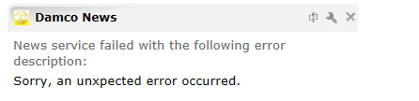

**Analysis**: Damco news feed was moved to new URL. URL configured in Administration section was browsed to check while a page not found error was encountered.

**Resolution**: New URL was received from business, which was configured from application GUI administration section and issue was resolved.

1. E-Learning Widget data not loading

**Analysis**: Issue was due to SMB net bios port disabled to access E-Learning flash file folders places on test environment from production environment

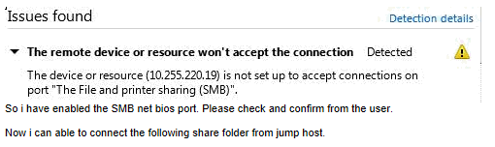

**Resolution**: IBM team enabled the port, which resolved the issue.